**DSL ORDER ENTRY FAILED**

Error message: HSIA BRASS error code 2414 from GIOM - error_message:DSLOrder_Entry processing stopped due to prequalification request failure.|

This error Occurs when address is not qualifying in prequal.

Resolution Steps:

1. Pick address from Queue Expediter Tool (http://attdslbe.cif.att.com/att/qtool.cgi) or BRASS DB.

Select street1,street2,city,state,zip,phone from service_address where dslserviceinstanceid='1467557_1';

1. Execute prequel in prequalification tool (<https://iomdsl.ipservices.att.com/ordering/prequal.cgi>)

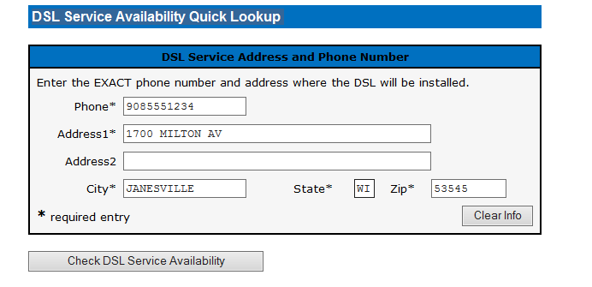

1. If address is qualifying in prequel, just retrigger the order.
2. If address fails in prequal , ask user to provide address and update that in service_address.

Update service_address set street1='',street2='',city='',state='',zip='' where dslserviceinstanceid='';

1. Once updated, retrigger(send giomhsia_oe to GIOM) the order using Queue expeditor tool.